7.1b Arithmetic Sequences Name____________________________ Block________

1. Determine which sequences is arithmetic. Find the common difference for those sequences which are arithmetic.
2. 5, 7, 9, 11…. b) 5, 3, 1, -1,…

c) 1, 3, 7, 15,… d) 3, 9, 27, 81,…

e) 7.1, 4.2, 1.3, -1.6,… f) 

g)  h) 

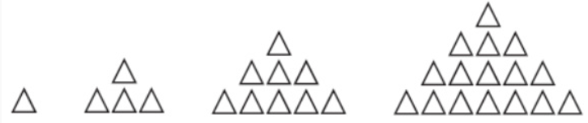

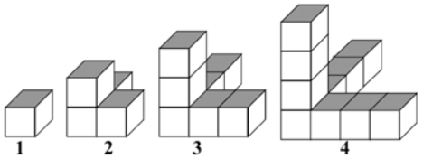

1. j)
2. Write the missing terms of the arithmetic sequences.
3. ____, ____, -2 , ____, ____ ; *d* = 4 b) ____, ____, 10 , ____, ____ ; *d* = -8

c) ____, ____,  , ____, ____ ; *d* =  d) ____, ____, -5 , ____, ____ ; *d* = -1.5

1. Calculate the first 4 terms of the arithmetic sequences with the given term and common difference.
2.  ;  b)  ; 

c) ; 

1. Complete the following pattern which describes each term in the arithmetic sequences.

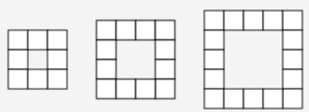

|  |  |  |
| --- | --- | --- |
| 1. 3, 9 , 15, 21, … | 1. 12, 9 , 6, 3, … |  |
|  | ___ | ___ |
|  |  |  |
|  |  |  |
|  |  |  |
|  |  |  |
|  |  |  |
|  |  |  |
|  |  |  |

1. Determine the indicated term.
2. 12, 5, -2, -9, …. *t*10 b) -1, 4, 9, 14, … *t*12

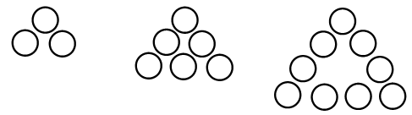

c) 16, 13, 10, 7, … *t*14 d) …, *t*20

1. Find the missing terms in the arithmetic sequences.
2. 2, ____, ____, 29
3. -5, ____, ____, ____, 43
4. 34, ____, ____, ____, ____, -1
5. The 5th term is 7 and the 12th term is -49. Determine the 6th,7th, 8th, 9th,10th and 11th terms.
6. Determine the 4th, 5th, 6th, and 7th terms in which *t*3 = -94 and *t*8 = -24
7. The graphs represent arithmetic growth. For each graph determine *d*, *t*1, *t5* and *t*n

*tn*

*tn*

*tn*

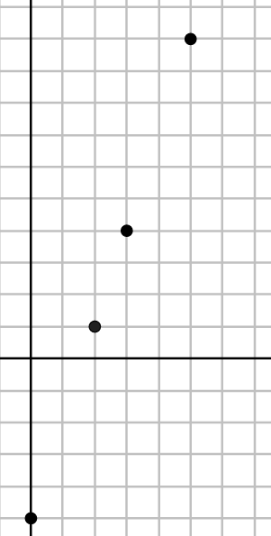

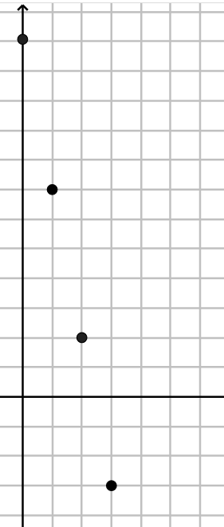

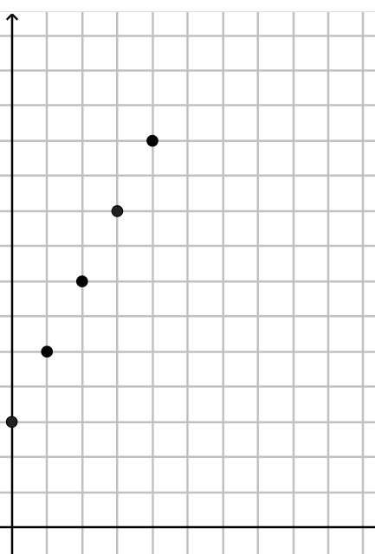

1. b) c)

*n*

*n*

*n*

1. Does the graph represent arithmetic growth? Why or why not?

Answers:

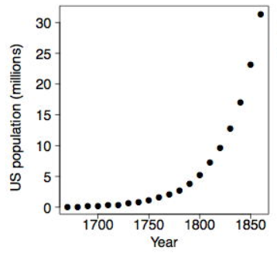

|  |  |  |  |
| --- | --- | --- | --- |
| 1a. Yes, d=2 | b. yes, d= -2 | c. no | d. no |
| e. yes, d=-2.9 | f. yes. d= - 3/5 | g. no | h. yes, d= -3*x*-2*y* |
| i. yes, d=3 | j. no |  |  |
| 2a. -10, -6, 2, 6 | | b. 26, 18, 2, -6 | |
| c. – 13/12 , -5/12 , 11/12 , 19/12 | | d. -2, -3.5, -6.5, -8 | |
| 3a. 8,5,2,-1 | b. -9,-4,1,6 | c. 25,23,21,19 |  |
| 4a, t30 =177, tn = 6*n*-3 | | 4b. t30 = -6, tn = -3*n*+15 | |
| 4c. t30 =124, tn = 4*n*+4 | | 5a. -51 | 5b. 54 |
| 5c. -23 | 5d. 60 | 6a. 11,20 | 6b. 7,19,31 |
| 6c. 27,20,13,6 | 6d. -1,-9,-17,-25.-33.-41 | | 6e. -80,-66,-52,-38 |
| 7a. d=2, t1=5,t5=13, tn= 2*n*+3 | | . d= -5, t1=7, t5= -13 tn= -5*n*+12 | |
| 7c. d=3, t1= -2,t5=10, tn= 3*n*-5 | |  | |
| 8. No, a common difference/constant rate of change does not exist. | | | |