Math 10: Polynomials 5.4 **Common Factors**

Name: __________________________ Date: _________________________ Block: _________

1. **In each case, state the greatest common factor of the following sets of monomials.**
2. 7*m*, 14*m* b. 6*x*2, 9*x*3c*. bc*2, *bc*7

d. -8*xy*3, 18*x*2, *y* e. 10*x*5*z*6, 15*x*5*z*, 25*x*3*z*4 f. 24*ab*2, 9*ab*, 6*a*2*b*

g. 10*xy*, 16*xz*, 20*xyz* h. 2*x*3y, 4*x*3*y*4, 4*x*2*y*4 i. 28*x*4*y*3*z*3, 56*x*2*y*, 64*y*2*z*

1. **Complete the factoring in each case.**
2.  b. 

c.  d. 

e.  f. 

1. **Factor, if possible.**
2.  b.  c. 

d.  e.  f. 

f.  g.  h. 

i.  j.  k. 

1. **Factor, if possible.**
2.  b.  c. 

d.  e.  f. 

1. **Factor by grouping.**

a.  b.  c. 

d.  *e. (*hint: reorder*)

1. **a. What expression does each model of algebra tiles represent**

**b. What are possible dimensions of the model**



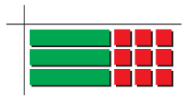

i. ii.

1. **A rectangle has an area that can be represented by the expression . The dimensions of the rectangle can be found by factoring the expression. Write possible expressions for the length and width.**

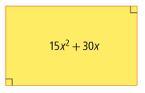

1. **Write an expression for the area of each shaded region**

**a. as a polynomial.**

**b. in factored form.**

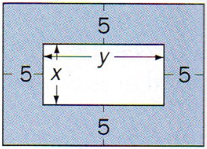

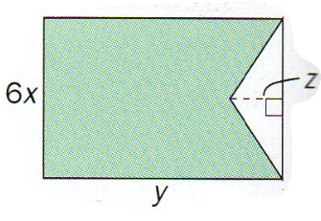

i. ii.

**Answers:**

1a.  b.  c.  d. 1 e.  f.  g.  h.  i. 2a.  b.  c.  d.  e.  f. 

3a.  b.  c.  d.  e.  f.  g. 

h.  i.  j.  k. 

4a.  b.  c.  d.  e.  f. 

5a.  b.  c.  d.  e. 

6i) a.  b.  ii) a.  b.  7.  by 

8i) a.  b.  ii) a.  b. 