Math 10: Polynomials 5.3 **Special Products**

Name: __________________________ Date: _________________________ Block: _________

1. **Expand and simplify.**

a.  b. 

c.  d. 

e.  f. 

g.  h. 

i.  j. 

k.  l. 

m. 

Vera is installing a kitchen window that has a height to width ratio of 3:2. The window frame adds 4 cm to the width and 8 cm to the height.

a. Write a polynomial expression that represents the total area of the

window, including the frame. Multiply and combine like terms.

b. Calculate the area when *x* = 12 cm.

2.

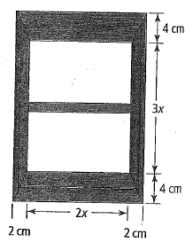

A circle is inset into a square with a side length of 6*x* + 4, as shown.

Write an expression to represent the area of the circle.

Multiply, and then combine like terms.

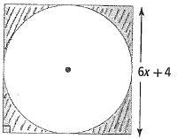

3.

**Answers:**

1a.  b.  c.  d.  e. 

f.  g.  h.  i. 

j.  k.  l.  m. 

2a.  b.1232 cm2 3. 