Math 10: Polynomials 5.2 **Multiplying Polynomials**

Name: \_\_\_\_\_\_\_\_\_\_\_\_\_\_\_\_\_\_\_\_\_\_\_\_\_\_ Date: \_\_\_\_\_\_\_\_\_\_\_\_\_\_\_\_\_\_\_\_\_\_\_\_\_ Block: \_\_\_\_\_\_\_\_\_

**Multiplying Binomials:**

Complete the diagrams to determine the binomial products.

b)

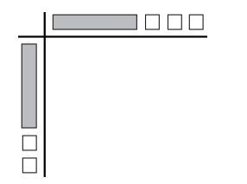

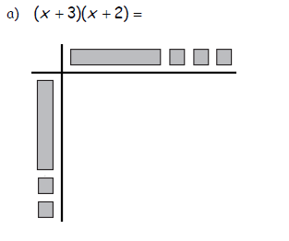

  Multiplying polynomials using the distributive property

Each term in the first polynomial gets distributed to each term in the second polynomial

**F -**

**O -**

**I -**

**L -**

C:\E3B31A85\053CFCD3-055E-4D02-80B6-6498CD209DE3_files\image005.png

C:\E3B31A85\053CFCD3-055E-4D02-80B6-6498CD209DE3_files\image004.png

C:\E3B31A85\053CFCD3-055E-4D02-80B6-6498CD209DE3_files\image003.png

1. Expand and Simplify.

a.  b.  c. 

d.  e.  f. 

g.  h.  i. 

1. Expand and Simplify.

a.  b.  c. 

1. Expand and Simplify.

a.  b.  c. 

1. Expand and Simplify.

a.  b.  c. 

1. Find the area and perimeter of the following figures.



a. b.











**Answers:** 1a.  b.  c.  d.  e.  f.  g. 

h.  i. 

2a.  b.  c.  3a.  b.  c. 

4a.  b.  c. 

5a. Area:  Perimeter:  b. . Area:  Perimeter: 