FPC 10 2.3a Volume of Prisms, Cylinders & Spheres

Name _________________________________ Date_________________ Blk_____

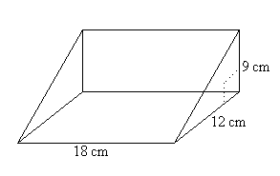

1. Calculate the volume of each prism.

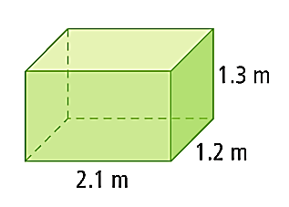

a) b)

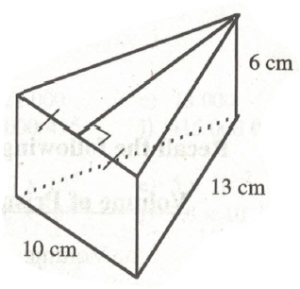

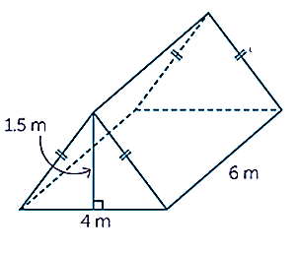

c) d)

1. Calculate the volume of each of the following.

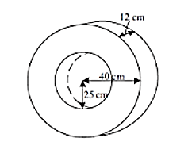

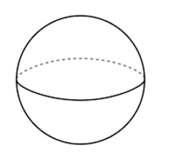

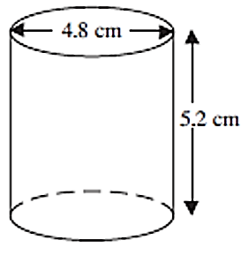

a) b) c)

15 cm

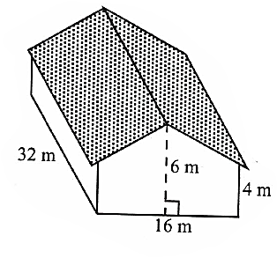

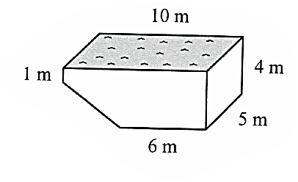

d) e)

1. If a sphere has a volume of 250 m3, what is its radius, to the nearest tenth of a metre?
2. A cube has a volume of 0.512 litres. Determine the length of each side of the cube in cm.
3. A pup tent in the shape of a triangular prism has a triangular entrance with an area of 8 m2. If the space in the tent has a volume of 11.6 m3, determine the length of the tent to the nearest *m*.
4. Two water pipes of the same length have a radius of 3 cm and 4 cm. If these two pipes are replaced by one pipe of the same length, what must be the radius of the new pipe if the volume is the same?
5. A new style of blue jeans was marketed in a cylindrical can. An engineering design company designed a can with a volume of 8000 cm3. The designer decided that the can should be 40 cm high. What is the radius of the can, to the nearest centimetre?
6. A Canadian $2 coin is 28 mm in diameter. The outer ring is made of a nickel alloy. The inner core has a diameter of 16 mm and is made of a copper alloy. The thickness of the coin is 1.8 mm. Calculate the volume of the nickel alloy in the coin



a) in cubic millimetres b) in cubic centimetres

1. The edges of a rectangular prism are 2*x*, 3*x* and 8*x*, units long. The volume of the prism is 20 250 cubic units. What is the value of y
2. A sphere fits exactly into a cube. What is the ratio of the volume of the sphere to the volume of the cube?

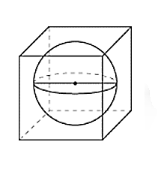

1. Three tennis balls are packed tightly in two different containers. What is the ratio of the volume of the tennis balls to the volume of the box in figures a and b?

B

A

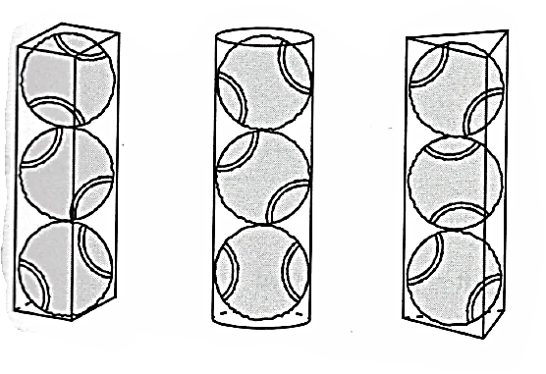

C

**Answers:**

**1**a. 3.3 m3 b. 1944 cm3 c. 18 m3 d. 360 cm3 **2**a. 94.1 cm3 b. 36 757 cm3 c. 1767 cm3 d. 170 m3 e. 2560 m3

**3**. 3.9 m **4**. 8 cm **5**. 1.45 m **6**. 5 cm **7**. 8 cm **8**a. 746 mm3 b. 0.75 cm3  **9**. 7.5 **10**.  **11**a.  b. 