FPC 10 2.3a Volume of Prisms & Cylinders

Name _________________________________ Date_________________ Blk_____

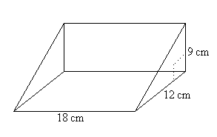

1. Calculate the surface area of each prism.

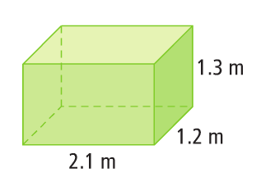

a) b)

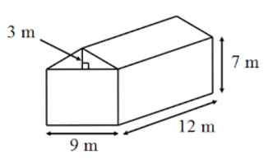

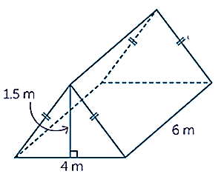

c) d)

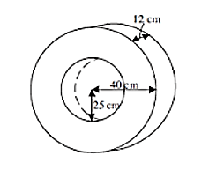

1. Calculate the surface area of each of the following.

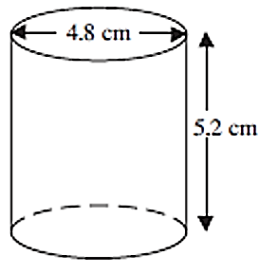

a) b)

1. Kelly cuts the lid from a cylindrical can containing soup. To correctly calculate the surface area of the can without the top lid, she could use the formula:

a)  b)  c)  d) 

1. For each of the following the surface area is given. Calculate the missing dimension.

a) b)

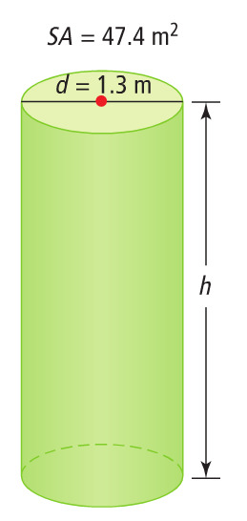

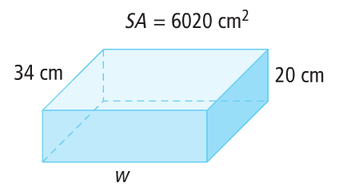

c) SA = 403.44 cm2

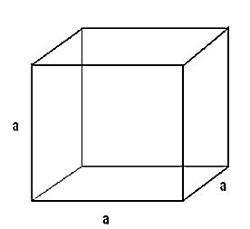

1. Calculate the surface area.

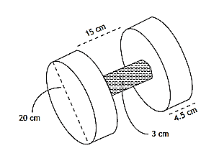

The photo shows a traditional Haida hand drum that has a diameter of cm and is cm deep. What is the minimum amount of hide used to make the drum if the hide covers only the top and lateral surfaces? Express your answer to the nearest square cm.

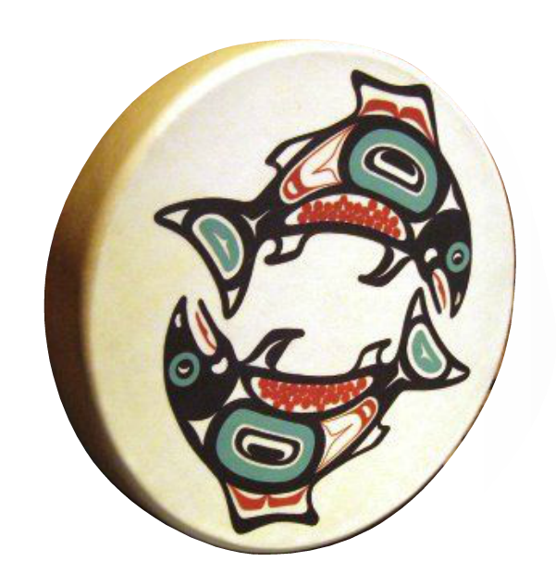

**Answers:**

**1**a. 13.62 m2 b. 756 cm2 c. 60 m2 d. 558.6 m2 2a. 114.6 cm2 b. 11 027 cm2 3. B

4a. 43.15 cm b. 11 m c. 8.2 cm 5. 1832.4 cm2 6. 1957.2 cm2