FPC 10 2.2b Surface Area of Pyramids, Cones & Spheres
Name _________________________________ Date_________________ Blk_____
- Calculate the surface area of each of the following pyramids.
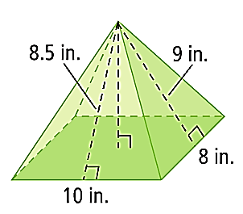
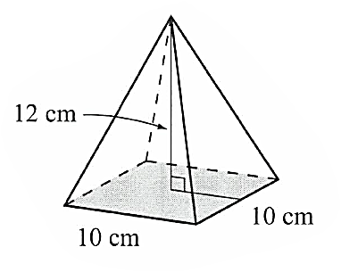
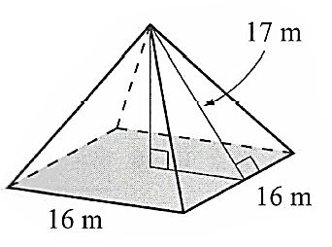
a) b) c)

- Calculate the surface area of each of the following cones.
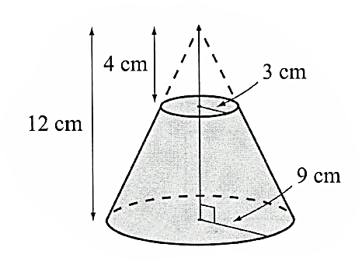
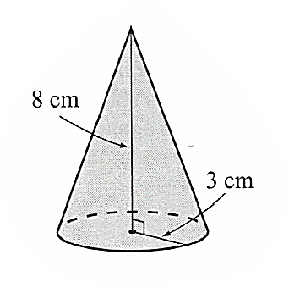
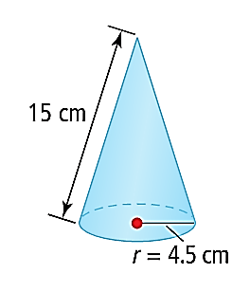
a) b) c)

- Calculate the surface area of the sphere.
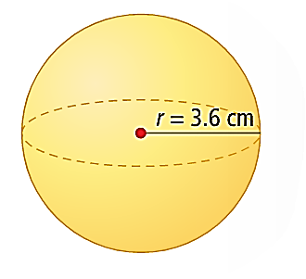

- A conical paper cup has a diameter of 6 cm and a height of 7 cm. How many square centimetres of paper are needed to make the cup?

- Earth has a diameter of approximately 13 000 km. Land forms about 29 percent of the surface of the Earth. Assume Earth is a sphere. Estimate the area of land on Earth.

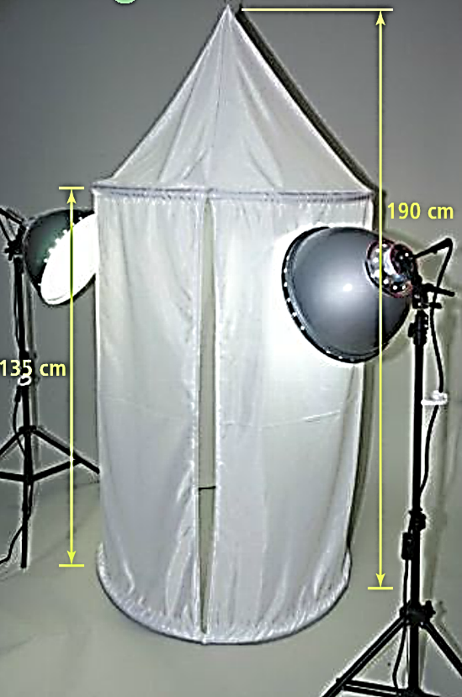
- Photographers often use a light tent to get the best lighting for items they photograph for museums, catalogues, or online sales. This tent is cylindrical with a conical roof. The diameter of the tent is 1 m, the height of the tent is 190 cm, and the cylindrical wall of the tent is 135 cm high. What is the surface area of the light tent, to the nearest tenth of a square metre?

- For each of the following, the surface are is given. Calculate the missing dimension.

a) SA = 91.4 m² b) SA = 741.4 cm² c) SA = 1475 m²
16 cm
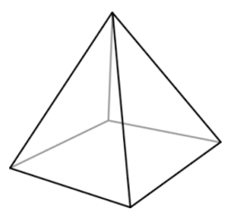
s
25 m
25 m
s
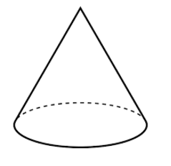
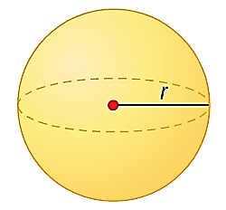

Answers:
1a. 800 m² b. 360 cm² c. 237 in² 2a. 276 cm² b. 109 cm² c. 660 cm² 3. 163 cm² 4. 72 cm² 5. 153 969 450 km²
6. 5.4 m² 7a. 2.7 m b. 21.5 cm c. 17 m

