FPC 10 1.1 Metric Measurement

Name _________________________________ Date_________________ Blk_____



G M k h da Unit d c m  n

1. Convert the following to the indicated units.

a) 7450 cm = ________________ m b) 0.85 km = ________________ m

c) 21 km = ________________cm d) 91 mm = ________________cm

e) 93.11 m = ________________cm f) 50 mm = ________________m

g) 45 m = ________________ km h) 26.93 cm = ________________mm

i) 670= ________________ mm j) 34 Gm = ________________ km

k) 3287 nm = ________________  l) 5775 Mm = ________________ Gm

1. Convert the following to the indicated units.

a) 67 KL = ________________ L b) 900 ml = ________________ L

c) 12.3 L = ________________ ml d) 31 mg = ________________ cg

e) 0.3765 kg = ________________ g f) 750 g = ________________ kg

g) 67 gigajoules = ________________megajoules h) 75 900 nm = ________________ cm

1. In wireless communications, the term "Hz" (pronounced *Hertz* after the name of 19th century scientist Heinrich Hertz) refers to the transmission frequency of radio signals in cycles per second. 1 **Hz** equals one cycle per second.

a) Determine the definition of a **MHz** (Megahertz) and a **GHz** (Gigahertz).

b) [Wi-Fi](https://www.lifewire.com/what-is-wifi-816557) networks all operate in either 2.4 GHz or 5 GHz bands. Convert to Mhz

c) Traditional cordless phones operate in a 900 MHz range. Convert to GHz.

1. Each sentence is incorrect. Move or insert a decimal point, to make the sentence correct.

a) The average female height is 1.63 cm.

b) The length of a Persian rug is 0.37 m.

c) A stack of 20 loonies is 391 cm high.

d) The average foot is 2.8 mm long.

e) The highest mountain in Canada is Mt. Logan, Yukon at 59.56 m.

f) The longest river in Canada is the Mackenzie at 4241 m.

g) The highest waterfall in Canada is Delta Falls, BC at 4.4 m.

1. On a map of Alberta, 4 cm represents 62 km. If the actual distance from Calgary to Lethbridge is 217 km, calculate the distance between Calgary and Lethbridge on this map.
2. A trundle wheel can be used to measure the walking distance between two locations.

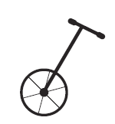

a) If the diameter of a trundle wheel is 40 cm, how far will a person have walked

when the wheel makes one full rotation?

b) If a person walks for half a km, how many times has the wheel rotated?

c) What will be the radius of a trundle wheel that rotates once for every meter the trundle wheel is pushed?

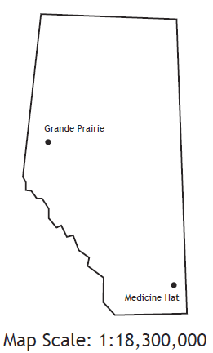

1. Determine the actual distance in km between Grande Prairie and Medicine Hat.
2. Use the map of part of the Northwest Territories to help answer the following questions.

a) Express the scale of the map as a ratio in lowest terms.

b) Determine the distance from Fort Simpson to Moose Ponds

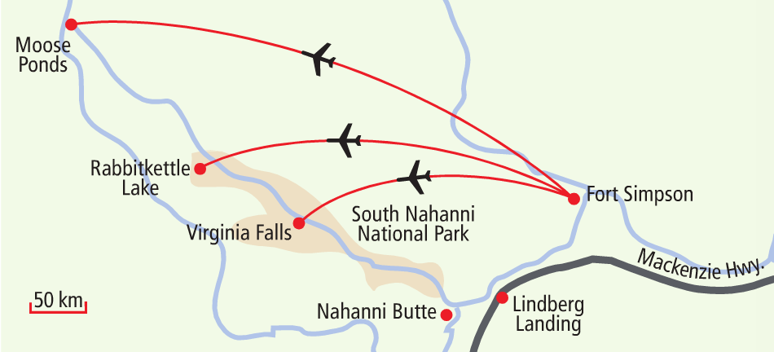

**Answers:**

**1**a. 74.5 b. 850 c. 2 100 000 d. 9.1 e. 9311 f. 0.05 g. 0.045 h. 269.3 i. 0.67 j. 34 000 000 k. 3.287 l) 5.775

2a. 67 000 b. 0.9 c. 12 300 d. 3.1 e. 376.5 f. 0.75 g. 67 000 h. 0.00759

3a. MHz = 1 000 000 h; GHz = 1 000 000 000 h b. 2400 MHz; 5000 MHz c. 0.9 GHz

4a. 163 b. 3.7 c. 3.91 d. 280 e. 5956 f. 4 241 000 g. 440

5. 14 cm 6a. 125.7 cm b. 397 c. 15.9 cm 7. 549 km 8a. 1:6 250 000 b. 494 km